**United States Department of Agriculture**

Food and Nutrition Service

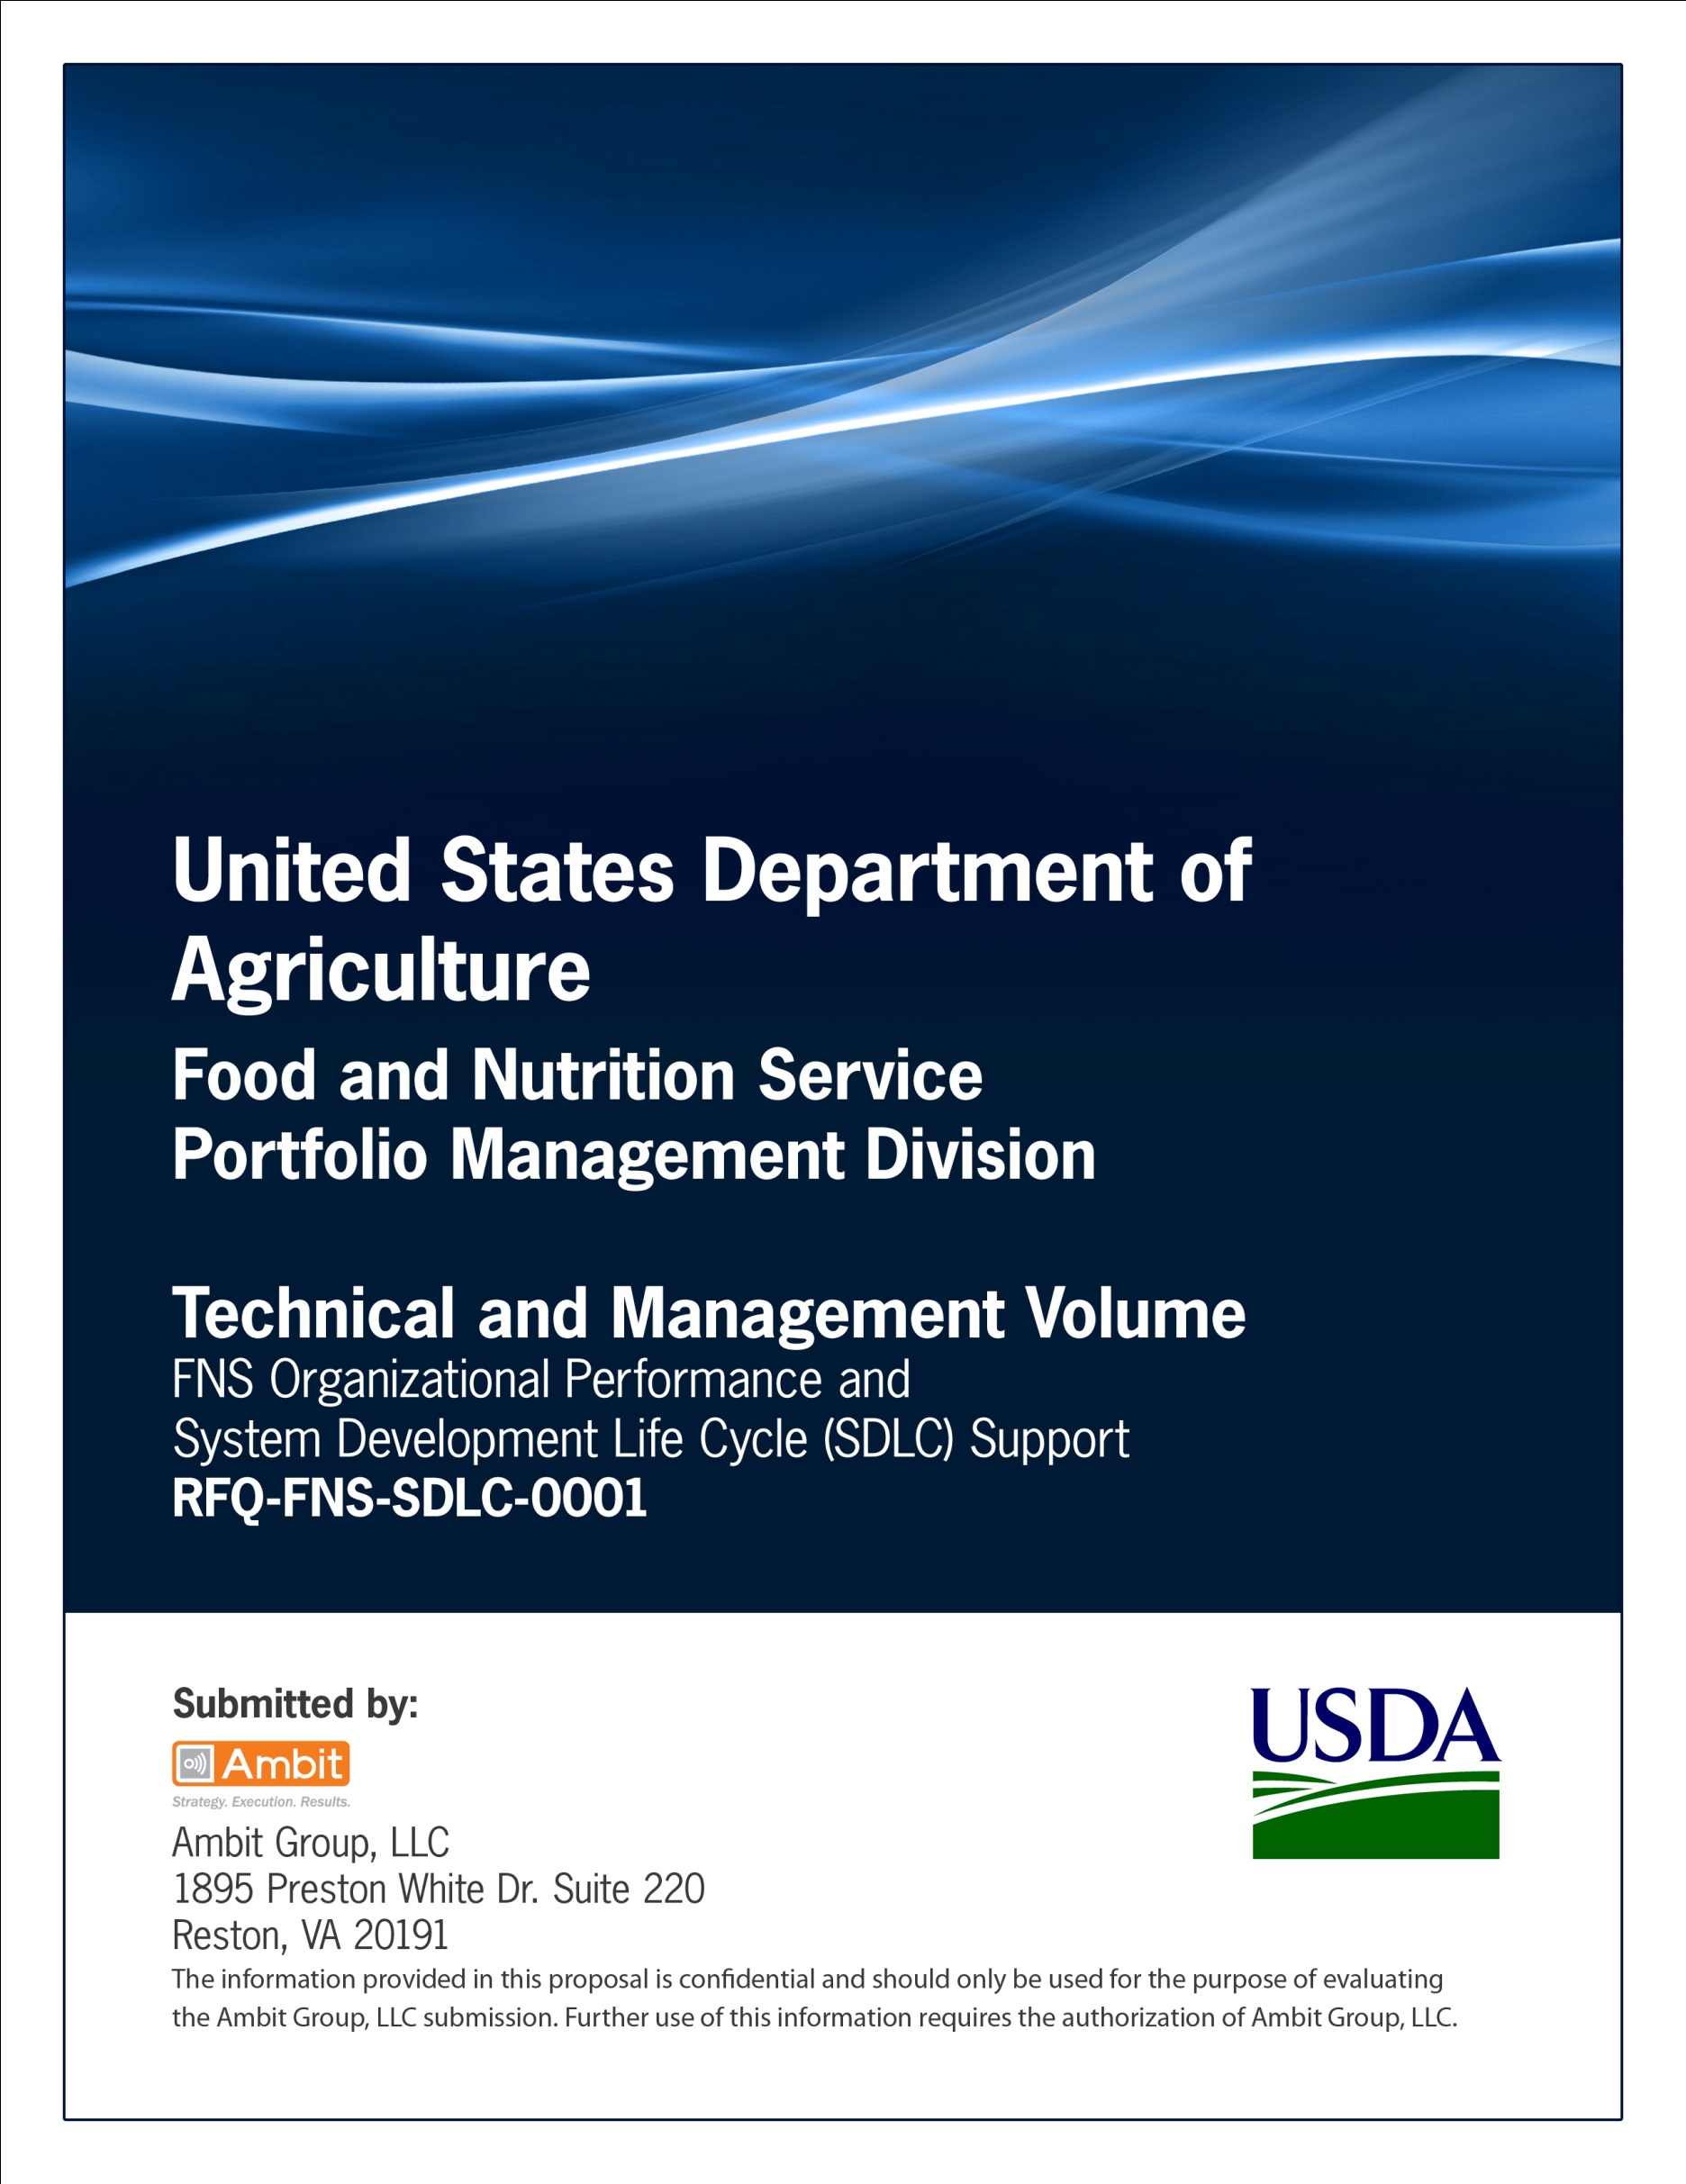

**Office of Information Technology**

**Portfolio Management Division (PMD)**

**FNS Acquisition Approval Request Template**

**for**

**[Project or System Name]**

**Version 1.1**

September 09, 2013

**Revision History**

|  |  |  |  |
| --- | --- | --- | --- |
| **Version** | **Date** | **Author** | **Change Description** |
| 1.0 | 03-19-2012 | IT Governance Branch (ITGB) | Created the document. |
| 1.1 | 09-09-2013 | IT Governance Branch (ITGB) | Re-formatted the document. |
| 1.2 |  |  |  |
| 1.3 |  |  |  |

**Contact Information**

|  |  |
| --- | --- |
| **Area of Concern** | **Contact Person** |
| IT Governance Lead | Kevin Russ |
| SDLC Coordinator | Syed Jaffery |
| ITIRB Coordinator | Sunny Dilawari |
| Portfolio Management Division Director, Chief Portfolio Officer | Jacqueline Butler |
| Program Management Branch Chief | Allison Willcox |

Contents

**United States**

**Department of**

**Agriculture**

Food and

Nutrition

Service

3101 Park

Center Drive

Alexandria, VA

22302-1500



TO: Yvonne Thomas Jackson

Associate Chief Information Officer

THROUGH: Jeffrey Tribiano

Associate Administrator &

Chief Operating Officer

FROM: Rory Schultz

Deputy Chief Information Officer

SUBJECT: Information Technology Acquisition Approval Request for [Investment Name]

**Executive Summary**

This document provides acquisition information for the United States Department of Agriculture (USDA) Food and Nutrition Service (FNS) Information Technology (IT) investment, [Investment name (acronym for investment)] (UII: [UII Number]). The estimated expenditure for this investment is [$XXX,XXX] for Fiscal Year (FY) [XXXX]. The Acquisition Approval Request (AAR) is supported by checklist information in the following areas:

* Enterprise Architecture (EA)
* Enterprise Network Services (ENS)
* Capital Planning and IT Governance Division (CPIGD)
* Cyber Policy and Oversight (CPO)
* International Technology Service (ITS)
* National Information Technology Center (NITC)
* Electronic Government (eGOV)
* Innovations and Emerging Technologies (IET)
* Agriculture Security Operations Center (ASOC)
* Information Management Division (IMD)

This document is intended to provide key decision data to the USDA Office of the Chief Information Officer (OCIO) for purposes of acquisition approval. Agency AARs will use investment information and existing, Departmental contract vehicles to support Information Technology (IT) acquisitions whenever possible. Additional information may be found within the USDA Capital Planning Investment Repository (CIMR) system or requested, as needed, through the [Agency investment name].

**The AAR Level of Risk**

The level of an acquisition’s risk will be determined by the OCIO AAR Manager using an algorithm. The criteria used to determine the level of approval required for an AAR has been developed to assess the overall nature of the risk of the acquisition. The greater the level of assessed risk, the higher level of approval required. Each AAR will be evaluated to determine the level of approval.

1. **Background and Business Context**

Describe the proposed acquisition so that OCIO will understand its role within the broader business and technology environment.

1. **Mission and Program Support**

Briefly describe the purpose of the agency activities that will be supported by the proposed acquisition:

1. The related mission program(s) and/or business function(s) in terms of major inputs, outputs and customers
2. Current implementation software and hardware
3. Include any other federal agencies internal/external of USDA also using the proposed acquisition.
4. **Technical Support**

Describe the current technology implementation:

1. Include the range of services to be provided with this acquisition
2. Specify the technical support team to be provided
3. Include the number of technical support team to be used (onsite and offsite).
4. **Partnership Agreements**

If the acquisition supports a collaborative project with other USDA agencies or external organizations:

1. Briefly define/describe the USDA agencies or external organizations involved in the partnership;
2. Summarize the roles and responsibilities of each partner; and
3. Explain how the proposed acquisition supports the overall effort
4. **Implementation Progress**

If an AAR was submitted in the last fiscal year for the same investment or project, describe the changes that have occurred since that submission. Include such information as:

1. Current progress made, such as major milestones completed or deliverables produced
2. Improvements in business processes
3. New regulatory requirements or other events that caused changes in the overall approach or direction
4. Changes in funding availability, original schedule or project scope; and
5. If any significant delays, describe the cause
6. **Justification and Benefits**

The acquisition described in the AAR should be justified in terms of the value to the agency and/or the department to be obtained through fulfillment of the business and technical requirements. Explain the expected performance improvements from the proposed acquisition.

1. **Development/Modernization/Enhancement**

Application software might be justified in terms of:

* Legislative requirements or presidential directives
* Agency strategic plan support
* Changes in the external environment (e.g. incidents of disease, changes in international conditions, etc.)
* Business process efficiencies or cost reductions
* Legacy system retirement
* Program delivery effectiveness
* Customer interaction improvements
* Opportunities for acquisition cost sharing

Changes to the technology infrastructure could be described in terms of:

* Improved security
* Technology modernization
* Migration to enterprise architecture solutions

1. **Steady State Investments**

The justification for steady state investments should emphasize:

* Residual value of the solution in supporting business activities
* Projected plans for modernization or replacement
* The negative impact to the agency if this investment was not approve

1. **Acquisition Description**

AARs can include acquisitions in three broad categories. These are listed below with the detailed information required for each. (For telecommunications components and services, see section IX Telecommunications for additional information requirements.) Describe each item separately.

1. **Hardware** **(describe item individually)**

* Type (e.g., server, PDA, etc.)
* Business or operational requirement
* Original equipment manufacturer (OEM)
* Item name and model number
* Supplier
* Technical description
* Compliance with externally mandated requirements (e.g., HSPD-12, IPv6, etc.)
* Quality
* Planned location(s) or type of facility (e. g., George Washington Carver Center, field office, state office, etc.)
* Technical Reference Model classification

1. **Software (describe each component separately)**

**Product of application name.**

* Types:
* Business or administrative;
* Program delivery; and
* Technology infrastructure component (e.g., operating systems, database management systems, utilities, desktop tools).
* Source (e.g., commercial-off-the-shelf (COTS), custom development, open source, etc.) and supplier name.
* Compliance with internally and externally mandated requirements (see additional information in section VI.E).
* Version and release.
* Infrastructure components on which the software will be deployed.
* Number and type of licenses (e.g., named user, named device, unlimited enterprise-wide, etc.).
* Technical Reference Model Classification.
* Supporting software required (e.g., HTML, SOAP, Java or Basic tools, backup tools, etc.), including version and release, as required.
* The name of any existing or planned software application that is related to or affected by the proposed acquisition.

1. **Services**

* Description of work to be performed.
* Schedule of targeted completion dates for major tasks or deliverables.
* When the service includes application software development or modification, provide the name of any existing or planned application that is related to or affected by the services to be performed.
* When the AAR pertains to an existing project or contract to produce a specified product(s), describe the progress made during the prior year. AARs for on-going operations and maintenance, helpdesk support and similar repetitive tasks may not result in creation of a discrete product(s).

1. **Legislative or Departmental Requirements**

All applications and web pages developed or maintained under this contract are in compliance with the requirements outlined below.

* FNS will ensure compliance with USDA web page design standards presented in

DR 3430-001;

* FNS will ensure compliance with Section 508 of the Rehabilitation Act

amendments of 1998;

* FNS will ensure compliance and support for the Paperwork Reduction Act

(PRA) consistent with Office of Management and Budget (OMB) policies and USDA’s information collection processes and approvals, including System of Record Notices (SORN);

* FNS will ensure compliance with Federal and USDA records management

policies and regulations;

* FNS will ensure compliance with Federal and USDA privacy policy, including

Privacy Impact Assessments (PIA) and protection of PII;

* FNS will ensure that all application code is reviewed for vulnerabilities using the

International Business Machines (IBM) AppScan.  FNS will ensure that any application code not reviewable by IBM AppScan complies with the secure coding requirements as described in the OCIO memo dated June 2, 2008 on secure coding and testing requirements;

* FNS will ensure that all vendor products and new or modified application systems

comply with the Federal Desktop Core Configuration (FDCC) standards and

functional requirements as approved by OCIO;

* FNS will ensure that all USDA policies, procedures and practices safeguarding

PII are enforced;

* FNS will ensure that all contractor personnel who will work in a USDA facility or

have access to any USDA network have a completed National Agency Check and Inquiry (NACI) background investigation, at a minimum, and that they complete the mandatory USDA security awareness and privacy training at lease annually;

* FNS will ensure that components where applicable will integrate with USDA’s

eAuthentication Service.  All identity management and single sign-on practices will comply and be coordinated with USDA’s Homeland Security Presidential Directive-12 (HSPD-12) implementation;

* FNS will ensure that all new equipment and software is configured according to

USDA and federal guidelines for secure configurations;

* FNS will ensure that all software applications that are purchased, developed or

significantly enhanced will operate on a thin client workstation; and

* FNS will review the USDA OCIO International Technology Services (ITS) Blanket Purchase Agreements (BPAs) for all the software and hardware to be procured.

**Investment Contact Information**

|  |  |  |
| --- | --- | --- |
| **Sponsor:** | **Office Phone:** | **Email:** |
|  |  |  |
| **Project Manager:** | **Office Phone:** | **Email:** |
|  |  |  |
| **Investment Liaison:** | **Office Phone:** | **Email:** |
|  |  |  |
| **Agency CPO:** | **Office Phone:** | **Email:** |
|  |  |  |
| **Agency CIO:** | **Office Phone:** | **Email:** |
|  |  |  |
|  | | |